Case Study: Accounting Profit, Economic Profit, Economic Rent
The Evolution of the Ride-Hailing Market: A Microeconomic Perspective

Introduction
The taxi and ride-hailing industry is a perfect backdrop to understand various microeconomic concepts. With the advent of technological disruptors like Uber and Lyft, traditional taxi services have seen their market dynamics shift dramatically. This case study aims to evaluate supply, demand, and equilibrium dynamics while also analyzing the profitability at the driver level.

Uber and Lyft, peer-to-peer ride-sharing platforms, have revolutionized the transportation sector, challenging traditional taxi services and becoming a staple in urban mobility.

- The 1980s and 1990s saw a steady increase in traditional cabs, mirroring urbanization and the economic boom in these cities.

- The early 2000s continued this trend, but by 2010, rideshare platforms entered the market. In 2010, there were 141,615 licensed Yellow Cabs in NYC.

- Post-2010, the rise of Uber and Lyft is evident, with an exponential growth in their numbers, especially in tech-forward San Francisco.

- By 2020, the number of Uber/Lyft vehicles in each city surpasses traditional cabs by a considerable margin. The trend indicates a shift in preference among city dwellers and visitors towards rideshare platforms due to convenience, price transparency, and ease of use.

The taxi and ride-hailing industry is a vivid backdrop to understanding various microeconomic concepts, including accounting profit, economic profit, and rent. The emergence of platforms like Uber and Lyft has not only transformed the transportation landscape but also introduced new opportunities for individuals to earn above-normal returns on their specific skills and assets. This study evaluates supply, demand, equilibrium, and profitability interplay at the industry and driver level.

Additional Information

1. Efficiency:
- Resource Allocation: Uber's and Lyft's algorithms rapidly match drivers with riders, optimizing the utilization of vehicles.
- Real-world example: In New York City, the average wait time for an Uber is 2-3 minutes compared to 10-15 minutes for a traditional cab.
- Dynamic Pricing: Uber's surge pricing and Lyft’s Prime Time pricing adjust rates in real time based on demand.
- Real-world example: Prices can multiply during New Year’s Eve or major sporting events due to high demand.

2. Exchange and the Invisible Hand:
- Voluntary Exchange: Drivers benefit from flexible work hours, while riders enjoy convenience and competitive prices.
- Real-world example: During the 2018 NYC subway outage, many commuters switched to Uber and Lyft.
- The Invisible Hand: Individual drivers deciding to work during rush hours ensure availability.
- Real-world example: In San Francisco, the influx of drivers during the weekday rush ensures rides are readily available for tech professionals.

3. Externalities and Regulation:
- Positive Externalities: Potential decrease in individual car ownership, leading to reduced carbon emissions.
- Real-world example: A UC Berkeley study suggested that ride-sharing can decrease individual car ownership in urban areas.
- Negative Externalities: Cities like New York have seen increased traffic congestion partly attributed to the ride-sharing platforms' rise.
- Regulation: Cities like London have tried to enforce stricter regulations on Uber, impacting the platform's operation.
- Real-world example: In 2017, London's transport regulator refused to renew Uber's license, citing concerns about public safety.

Case Activities

Individual Worker Analysis
Examine a day in the life of four New York City individuals, mapping out expenses and earnings and contrasting this with a traditional job:
- Full-Time Uber driver
- Part-Time (50% workload) Uber driver
- Full-Time Yellow Cab driver
- Full-Time Traditional job

Create a side-by-side financial analysis for each individual similar to the following:
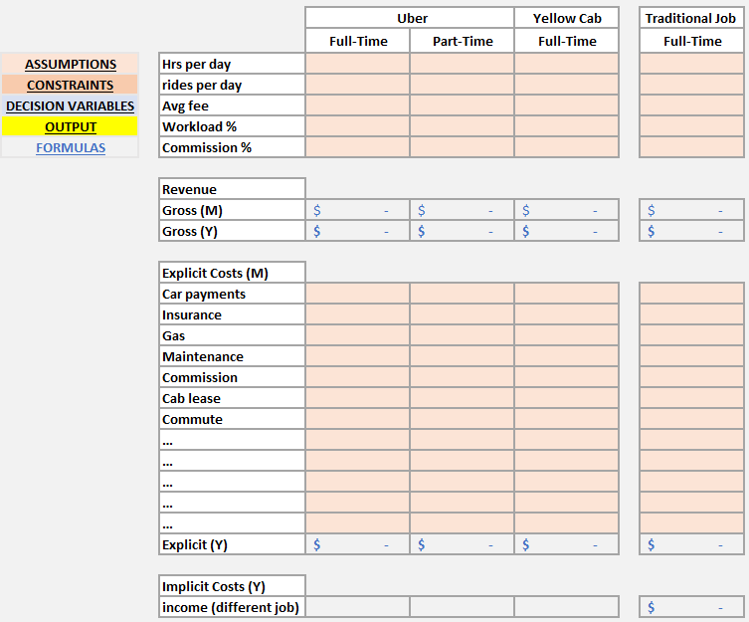

Industry Analysis
Analyze the rise of rideshare platforms, the impact on traditional cabs, and market saturation implications.
- The Effect of Market Forces on Economic Profit
- Invisible Hand and Cost-Saving Innovations

Demand and Supply Dynamics: Examine how supply and demand have evolved and how ridesharing has disrupted supply dynamics.
- Did the Supply Curve shift left or right?
- Demand curve?

Equilibrium Insights: Assess how market forces and ridesharing platforms have influenced equilibrium prices and quantities.
- What happened to the market price?
- Quantity demanded?

